**Deployment using Heroku**

**Lab ID: 6_2**

**Authors:**

**Madhuri Sarda : 21**

**Udaya Byreddy : 03**

**Introduction:**

Deploying the application using Heroku and accessing the application with the link.

**Design/Implementation:**

We have followed below steps to successfully complete this lab assignment:

**Step-1:** Creating the a new app in our heroku account

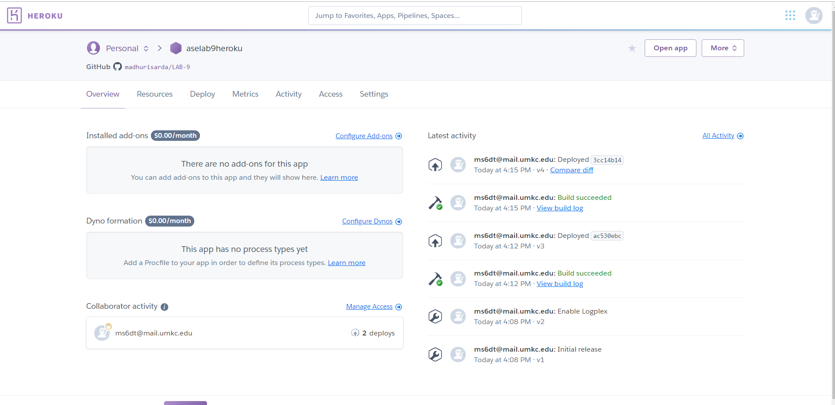

**Step-2:** Link the app with the git repository and add a Procfile and engines in package.json

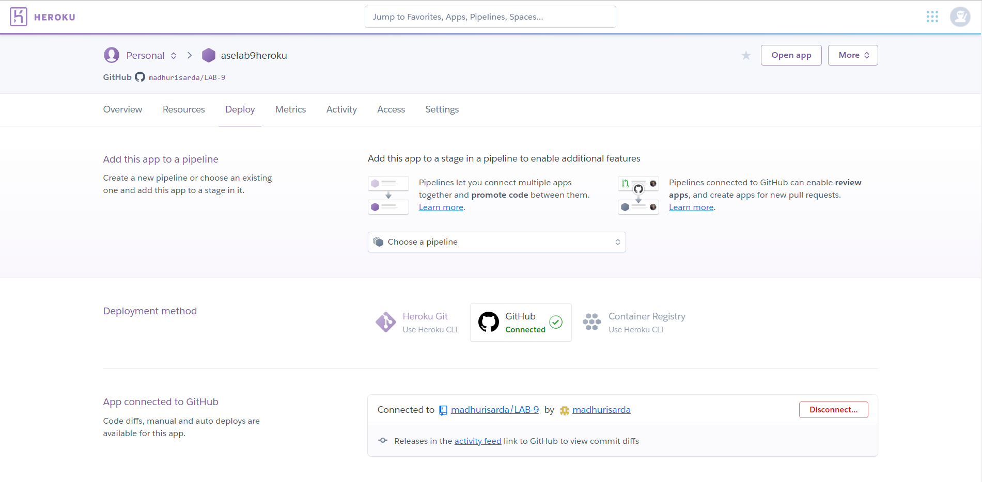



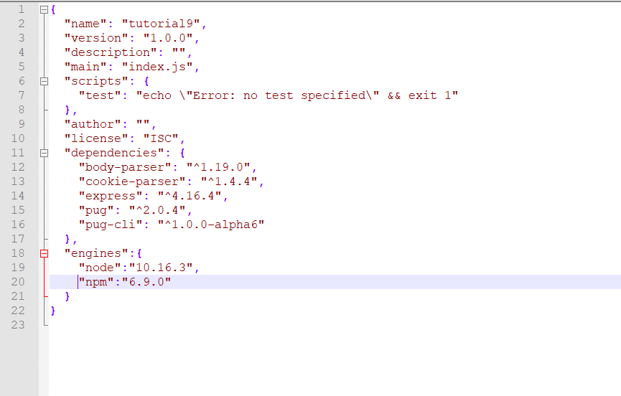

**Step-3:** Install Heroku CLI and type **heroku login.** The browser will open where u can Login.

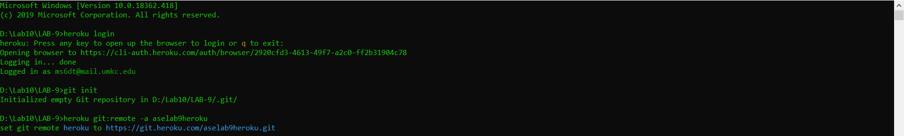

**Step-4: T**ype **git push Heroku master**

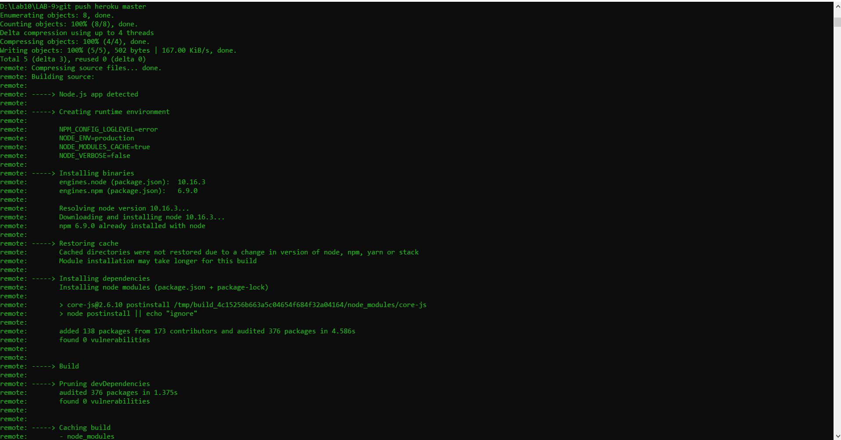

The link shows up which u can click and see your application running.

<https://aselab9heroku.herokuapp.com/>

